(Approx. 445 words)

President’s Message
Are your trips being tracked by your mobile devices?
By Jeff Wilkinson, President, Sun City Summerlin Computer Club, NV
September 2018 issue, The Gigabyte Gazette
www.scscc.org
pres.scscc (at) gmail.com

Computer Club and Friends:

At the Computer Club’s weekly Kaffee Klatch session, longtime member Captain Jack (Jack Spargo) brought up an interesting, and to many, unknown feature of the Android mobile operating system.

Apparently when logged in on an Android device, iPhone, or iPad device, Google tracks your GPS coordinates, nearby Wi-Fi networks, barometric pressure, and even takes a guess at your current activity. Jack recounted how he had discovered, somewhat by accident, that a recent trip to Canada was tracked, complete with stops and locations annotated.

So, after the meeting, I went home and took a look at my own activity, as obtained from my Samsung Galaxy S7 phone. Low and behold, there was a recent trip to the Bay Area complete with all my stops in Sunnyvale, San Jose, and San Francisco.

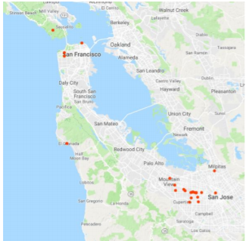
Location History, while not turned on by default, is part of Google Maps, Photos, Google Assistant, and the Google Chrome browser. And you can opt out of location history, although it is a number of screens deep in the phone’s settings for the Google App. Look for Data and Personalization tabs.

You can go to Google Account Help screen, Google My Activity -→ Activity Controls, which gives a page with options for turning features on or off. Google claims to use this information to personalize and enhance your experience across all of Google Services.

I don’t recall agreeing to all these tracking services when I installed Chrome, but I may have, or, as I suspect, the default setting is on. But Google still is able to track you through your use of Google Maps, weather updates, or Google searches.

If you Pause Web and App Activity, Google lets you know that you “…. may limit or disable more personalized experiences across Google services.” Even when paused, Google may temporarily use recent search information ostensibly to improve the quality of your search experience.
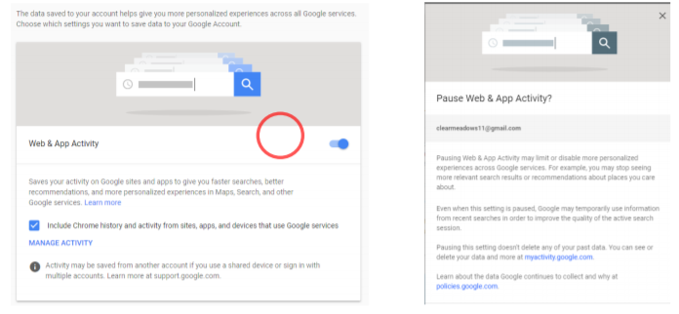
While not all bad, this location tracking does allow targeted advertising and more precise directions or responses to inquiries looking for a restaurant for instance, which can be very helpful.

A visit to your Google account page at Google My Activity, while interesting can also be a bit frightening as you realize all the information being collected.

So, while you can delete your activity data if you want to, if this tracking is of concern, you will have to keep on top of it since it appears many normal actions on your part can turn it back on.

